# Question No 2:

## PAC Chart

|  |  |
| --- | --- |
| Given Data | Required Results |
| - X coordinate - Y coordinate | Identify point lies in which Quadrant ( I, II, III, IV) Or if it lies on the axes (not in any quadrant) |
| - Compare coordinates with zero - Decide quadrant based on positive/negative values of x and y | Use if-else decision structure to check each condition separately |

## IPO Chart

|  |  |  |
| --- | --- | --- |
| Input | Process | Output |
| - X coordinate - Y coordinate | 1. Check if x == 0 or y == 0 → point lies on axis 2. If x > 0 and y > 0 → Quadrant I 3. If x < 0 and y > 0 → Quadrant II 4. If x < 0 and y < 0 → Quadrant III 5. If x > 0 and y < 0 → Quadrant IV | Display which quadrant the point lies in  Or display 'doesnot lie in any quadrant' |

## Algorithm

1. Start  
2. Input x coordinate  
3. Input y coordinate  
4. If x == 0 or y == 0, then display 'Point doesn't lie in any quadrant' and go to step 9  
5. If x > 0 and y > 0, display 'Quadrant I'  
6. Else if x < 0 and y > 0, display 'Quadrant II'  
7. Else if x < 0 and y < 0, display 'Quadrant III'  
8. Else if x > 0 and y < 0, display 'Quadrant IV'  
9. End  
**IC Chart**  
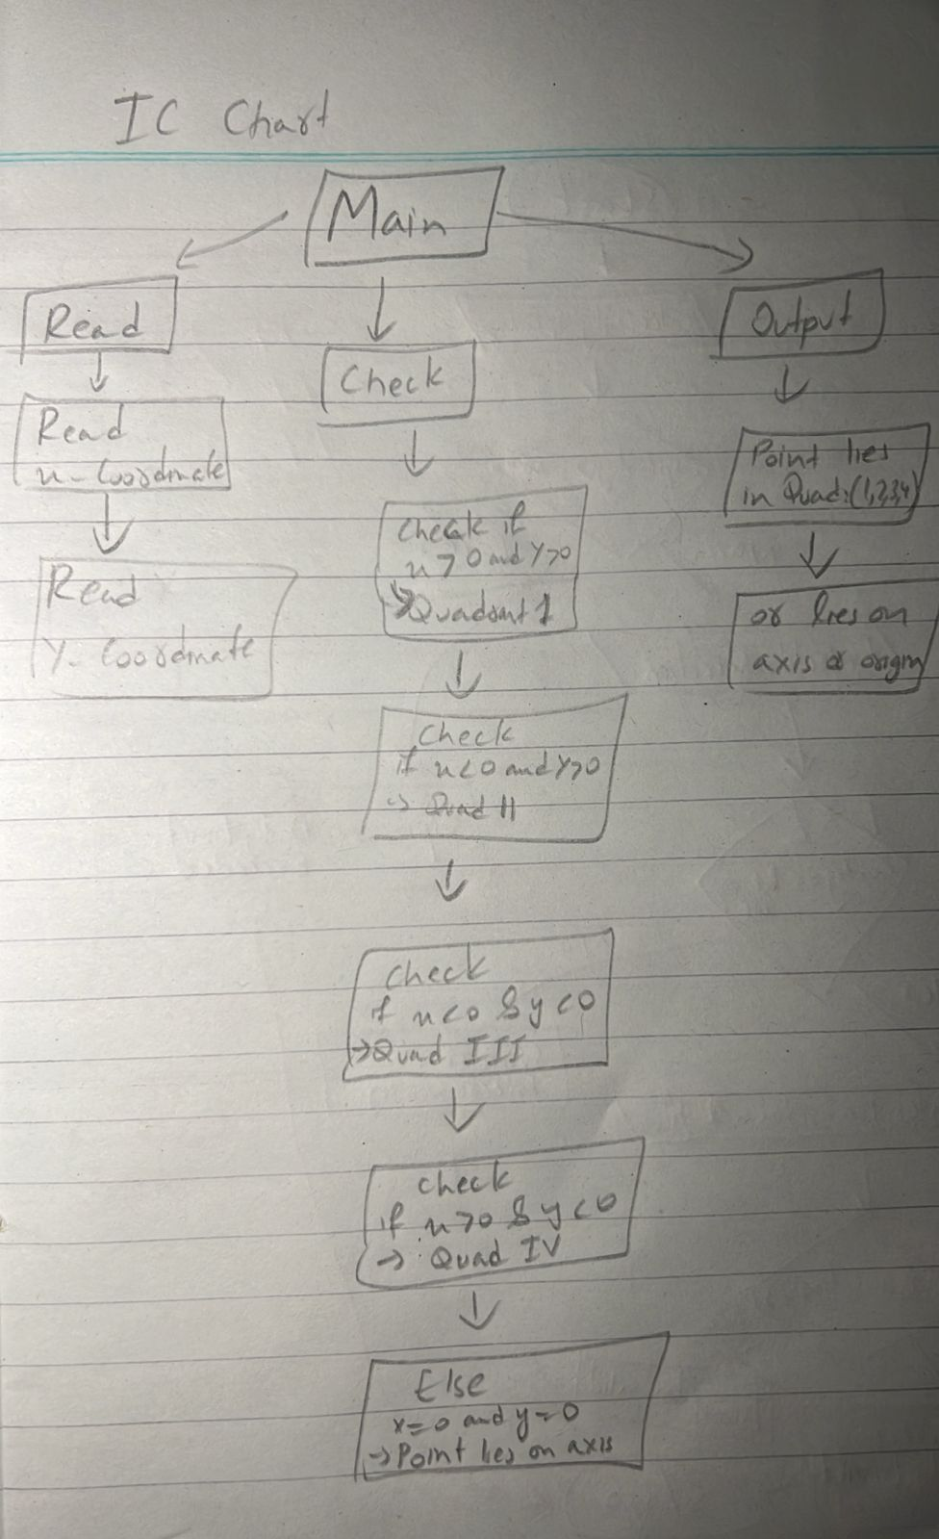

**Flowchart  
